
Mehran University of Engineering & Technology Shaheed Z.A Bhutto Campus Khairpur Mir's

Department of Software Engineering

Software Quality Engineering
Project Report
Internship Application Tracker REST API: Design, Implementation and Testing
Submitted By: K22SW004
Name: Sindhu Sahito
Name Of Teacher: Engr. Asmatullah Zubair
Department: Software Engineering
Class: 8th Semester Batch: 22-Batch
Subject: Software Quality Engineering
Date of Submission: 11-11-2026

Internship Application Tracker REST API: Design, Implementation and Testing
SW426 Software Quality Engineering | Problem Based Learning Report | Department of Software Engineering, Mehran University of Engineering and Technology, SZAB Campus, Khairpur Mir's

2. Problem Statement and Objectives
Students who apply for internships usually send many applications to different companies. Each application has a company, a role, a date, a status and some notes. Without a structured record it is easy to lose track of which applications are waiting, which led to interviews, and which were rejected.
The assignment asks for a database-connected REST API that manages records of a chosen entity, supports Create, Read, Update and Delete operations, exchanges data in JSON, and is tested with Postman for functionality, status codes, data accuracy and error handling. This project applies that task to internship applications.
Objectives
- Implement a REST API in Python with Flask, with five endpoints covering the four CRUD operations.
- Store records persistently in a SQLite database through SQLAlchemy.
- Exchange all request and response data in JSON.
- Return appropriate HTTP status codes (200, 201, 400, 404, 405, 409, 415 and 500) with clear JSON error messages.
- Validate required fields, data types, the date format, status values and text lengths.
- Test every endpoint in Postman, including invalid data, missing fields, nonexistent IDs and deleted records.
- Verify the database changes after create, update and delete operations.
- Document the implementation, the test cases and the results, and publish the source code on GitHub.

3. Chosen Entity and Attributes
The chosen entity is an Internship Application. One record describes one application sent to one company for one role.
Attribute | Data type | Required | Rules | Description
id | Integer, primary key | Generated | Unique, auto-incremented, never reused, not accepted in request bodies | Identifies one application and is used in URLs
company_name | Text, up to 120 characters | Yes | Not empty after trimming spaces | Company applied to
role | Text, up to 120 characters | Yes | Not empty after trimming spaces | Position applied for
application_date | Date | Yes | Exact format YYYY-MM-DD and a real calendar date | Date the application was sent
status | Text, up to 20 characters | Yes | Exactly one of Applied, Interview, Accepted, Rejected (case-sensitive) | Progress of the application
location | Text, up to 120 characters | No | A string or null | City or Remote
notes | Long text, API limit 1000 characters | No | A string or null | Free comments

4. Tools, Technologies and Database Used

4.1 Technologies
Component | Tool | Purpose
Programming language | Python 3.14.2 | Application code
Web framework | Flask (>=3.0, <4.0); installed version [ADD from pip list] | Routes, requests and JSON responses
ORM | SQLAlchemy through Flask-SQLAlchemy (>=3.1, <4.0); installed versions [ADD from pip list] | Maps the Internship class to a table
Database | SQLite (built into Python), file instance/internships.db | Persistent storage
Data format | JSON | Request and response bodies
API testing | Postman [ADD version] with Collection Runner | Manual and automated tests
Database inspection | DB Browser for SQLite 3.13.1 (read-only) and the helper script show_db.py | Checking stored records
Editor | Visual Studio Code | Development
Environment | Python virtual environment (.venv), pip 25.3, Windows [ADD version] | Isolated dependencies
Version control | Git and GitHub | Source code hosting

Flask was chosen because it is small and easy to explain. SQLite needs no database server, which suits a single-user student project.

4.2 Project files
File | Purpose
app.py | The whole application: configuration, model, validation, routes and error handlers
requirements.txt | Python dependencies
show_db.py | Helper that prints the tables and rows of the SQLite database
internship_api_tests.postman_collection.json | Postman collection with 28 requests and test scripts
README.md | Setup and usage instructions
.gitignore | Excludes .venv, the database file and generated files from Git

4.3 Starter code and my changes

Area | Starter code | This project
Structure and model | Single app.py, model with the same seven fields, five CRUD routes | Kept
Update (PUT) | Accepted partial updates | PUT replaces the whole record and needs all required fields, as in the assignment example
ID in the URL | Non-numeric IDs gave a generic not-found message and a very large ID caused an unhandled server error | IDs are validated and invalid IDs return a JSON 400
Deleted IDs | Could be reused by new records | AUTOINCREMENT prevents reuse
Duplicates | Stored twice | Unique rule with a 409 Conflict response (optional)
Date validation | Depended on the Python version | Strict YYYY-MM-DD check
Text length | Not checked | Limits checked and a 400 returned
Unknown fields | Handled differently in POST and PUT | Rejected consistently with a 400
JSON parsing | Malformed JSON and a non-object body gave the same message | Separate messages, plus 415 for a wrong content type
Error handlers | 404 and 405 | Added a JSON handler for unexpected server errors (500)
Postman | Five example requests | 28-request collection with automated test scripts
Inspection tool | None | show_db.py added

4.4 Running the project
python -m venv .venv
.\.venv\Scripts\Activate.ps1
python -m pip install -r requirements.txt
python app.py

The server then runs at http://127.0.0.1:5000. The database file instance/internships.db is created automatically on the first start.
Figure 4.2: browser showing http://127.0.0.1:5000/ with the API overview JSON
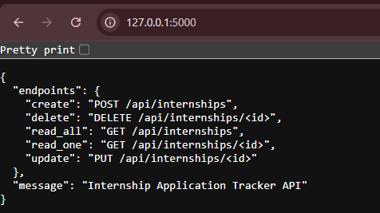

5. Database Design and Schema
The database has one application table, internship, created by SQLAlchemy from the Internship class in app.py when the application starts (db.create_all()). SQLite also creates the internal table sqlite_sequence, which records the last ID used so that IDs are never reused.
CREATE TABLE internship (
id INTEGER NOT NULL PRIMARY KEY AUTOINCREMENT,
company_name VARCHAR(120) NOT NULL,
role VARCHAR(120) NOT NULL,
application_date DATE NOT NULL,
status VARCHAR(20) NOT NULL,
location VARCHAR(120),
notes TEXT,
CONSTRAINT uq_company_role_date UNIQUE (company_name, role, application_date)
)
- The primary key id identifies each row.
- NOT NULL marks the four required fields. location and notes may be empty.
- The UNIQUE constraint rejects duplicate applications.
- SQLite does not enforce VARCHAR lengths by itself, so the API validates text lengths before saving.
- The file is created at instance/internships.db inside the project folder. This path was confirmed from the running application (the full path is shown in Figure 5.1).
Figure 5.1: DB Browser for SQLite, Database Structure tab, with the internship table expanded and the file path visible in the title bar
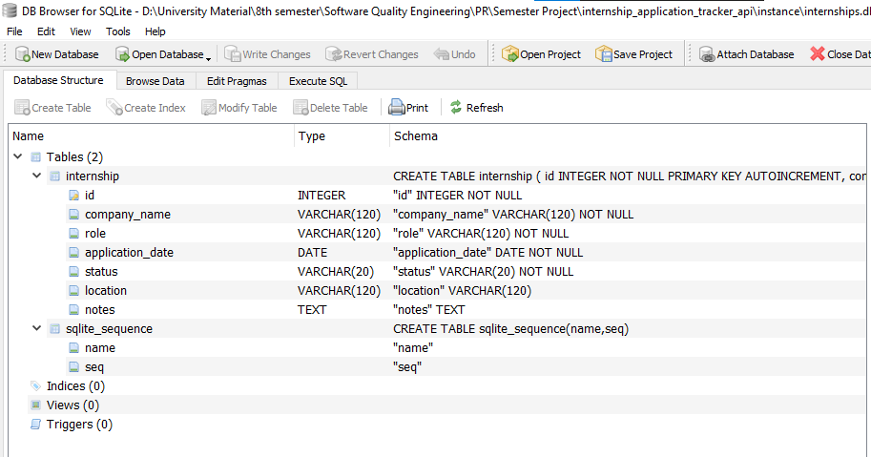
Figure 5.2: output of python show_db.py showing the CREATE TABLE statement

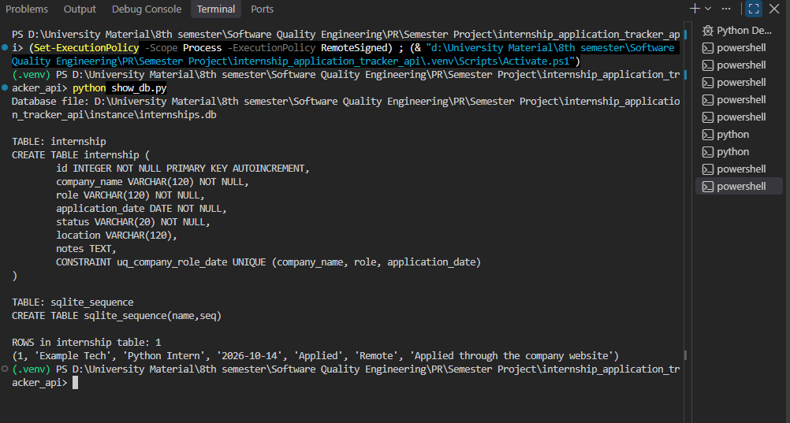

6. API Endpoint Documentation
Base URL: http://127.0.0.1:5000. All request and response bodies are JSON. Requests with a body must send the header Content-Type: application/json.
Operation | Method | URL | Success code
Create | POST | /api/internships | 201 Created
Read all | GET | /api/internships | 200 OK
Read one | GET | /api/internships/{id} | 200 OK
Update | PUT | /api/internships/{id} | 200 OK
Delete | DELETE | /api/internships/{id} | 200 OK

GET / returns an overview of the endpoints (200 OK) and is used to check that the server is running.

6.1 Create: POST /api/internships
Adds a new application. Request body:
{
"company_name": "Example Tech",
"role": "Python Intern",
"application_date": "2026-10-14",
"status": "Applied",
"location": "Remote",
"notes": "Applied through the company website"
}
Response 201 Created (the saved record, with the generated id):
{
"application_date": "2026-10-14",
"company_name": "Example Tech",
"id": 1,
"location": "Remote",
"notes": "Applied through the company website",
"role": "Python Intern",
"status": "Applied"
}
Errors: 400 (missing, invalid or unknown fields, malformed JSON), 409 (duplicate record), 415 (content type is not JSON).

6.2 Read all: GET /api/internships
No request body. Response 200 OK: a JSON array of records in ascending id order, each with the structure shown in 6.1. An empty table returns [].

6.3 Read one: GET /api/internships/{id}
No request body. Response 200 OK: one JSON object with the structure shown in 6.1. Errors: 404 if no record has that id, 400 if the id is not a positive whole number. Example error:
{
"error": "Internship application not found"
}

6.4 Update: PUT /api/internships/{id}
Replaces an existing record. The body must contain all four required fields. The optional fields location and notes are set to null if they are left out. Example body:

{
"company_name": "Example Tech",
"role": "Python Intern",
"application_date": "2026-10-14",
"status": "Interview",
"location": "Remote",
"notes": "Interview scheduled for next week"
}
Response 200 OK: the updated record (same id, new values). Errors: 400 (invalid id or body), 404 (record not found, checked before the body), 409 (the new values would duplicate another record), 415.

6.5 Delete: DELETE /api/internships/{id}
No request body. Response 200 OK:
{
"id": 2,
"message": "Internship application deleted successfully"
}
Errors: 404 (record not found), 400 (invalid id). A GET request for the deleted id afterwards returns 404.

6.6 Validation rules
Field | Rule
company_name, role | Required, a string, not empty after trimming, at most 120 characters
application_date | Required, a string in the exact format YYYY-MM-DD, a real calendar date
status | Required, exactly Applied, Interview, Accepted or Rejected
location | Optional, a string or null, at most 120 characters
notes | Optional, a string or null, at most 1000 characters
Any other field (including id) | Rejected with 400
URL id | A positive whole number that fits the database

6.7 Status codes
Code | Meaning | When it is returned
200 OK | Success | Read, update and delete
201 Created | Record created | POST
400 Bad Request | Invalid input | Missing or invalid fields, malformed JSON, invalid id
404 Not Found | Not found | Record or endpoint does not exist
405 Method Not Allowed | Unsupported method | For example PATCH, or DELETE without an id
409 Conflict | Duplicate | Same company, role and date already stored
415 Unsupported Media Type | Wrong content type | Body not sent as application/json
500 Internal Server Error | Unexpected failure | Returned as JSON by the safety-net handler
Error responses use the form {"error": "message"} and sometimes add details such as fields, allowed_values or received.

7. Postman Test Cases

7.1 Test setup
All tests were run in Postman against http://127.0.0.1:5000 with the Flask server running locally. The requests are saved in the collection Internship Application Tracker API (SW426), imported from internship_api_tests.postman_collection.json. The base URL is stored in the collection variable baseUrl. Every request has a test script that checks the status code and the response body. IDs are not hard coded: TC-01 stores the real id in the variable recordId. For each test the request was sent once, the status code and body were compared with the expected result, a screenshot was taken, and the database was inspected with show_db.py or DB Browser for SQLite.

7.2 CRUD test cases
Complete the Actual status and Result columns from your own screenshots. If the observed status matched the expected status, write the same code and Pass.
ID | Objective and request | Expected status | Expected result and database change | Actual status | Result
TC-01 | Create a valid record. POST /api/internships with all fields | 201 Created | Saved record with a generated id. One new row in the database | 201 Created | Pass
TC-02 | Retrieve all records. GET /api/internships | 200 OK | JSON array containing the TC-01 record. No database change | 200 OK | Pass
TC-03 | Retrieve one record. GET /api/internships/{recordId} | 200 OK | Single JSON object with the same data as TC-01 | 200 OK | Pass
TC-04 | Update an existing record. PUT /api/internships/{recordId} with status Interview and new notes | 200 OK | Updated record with the same id. The row changes and the row count stays the same | 200 OK | Pass
TC-05 | Delete an existing record. DELETE /api/internships/{tempId} (a disposable record) | 200 OK | Confirmation message. The row is removed from the database | 200 OK | Pass
TC-06 | Retrieve the deleted record. GET /api/internships/{tempId} | 404 Not Found | Error: Internship application not found | 404 Not Found | Pass

TC-05 uses a disposable record created by the setup request TC-05-prep, so the main record stays available for the other tests.
Screenshots:
- Figure 7.1: TC-01.png (POST, 201 Created)
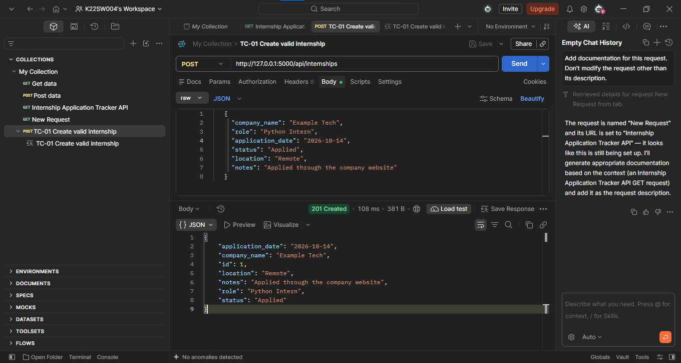
- Figure 7.2: TC-02.png (GET all, 200 OK)
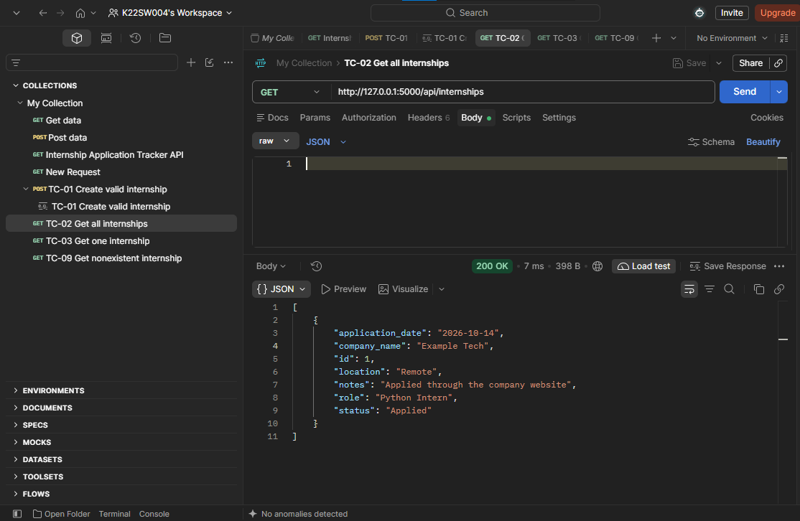
- Figure 7.3: TC-03.png (GET one, 200 OK)
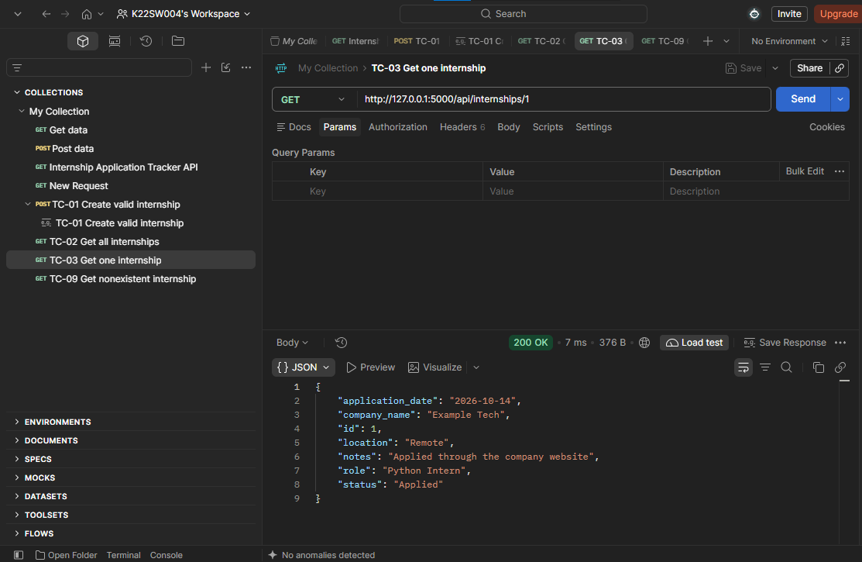
- Figure 7.4: TC-04.png (PUT, 200 OK)
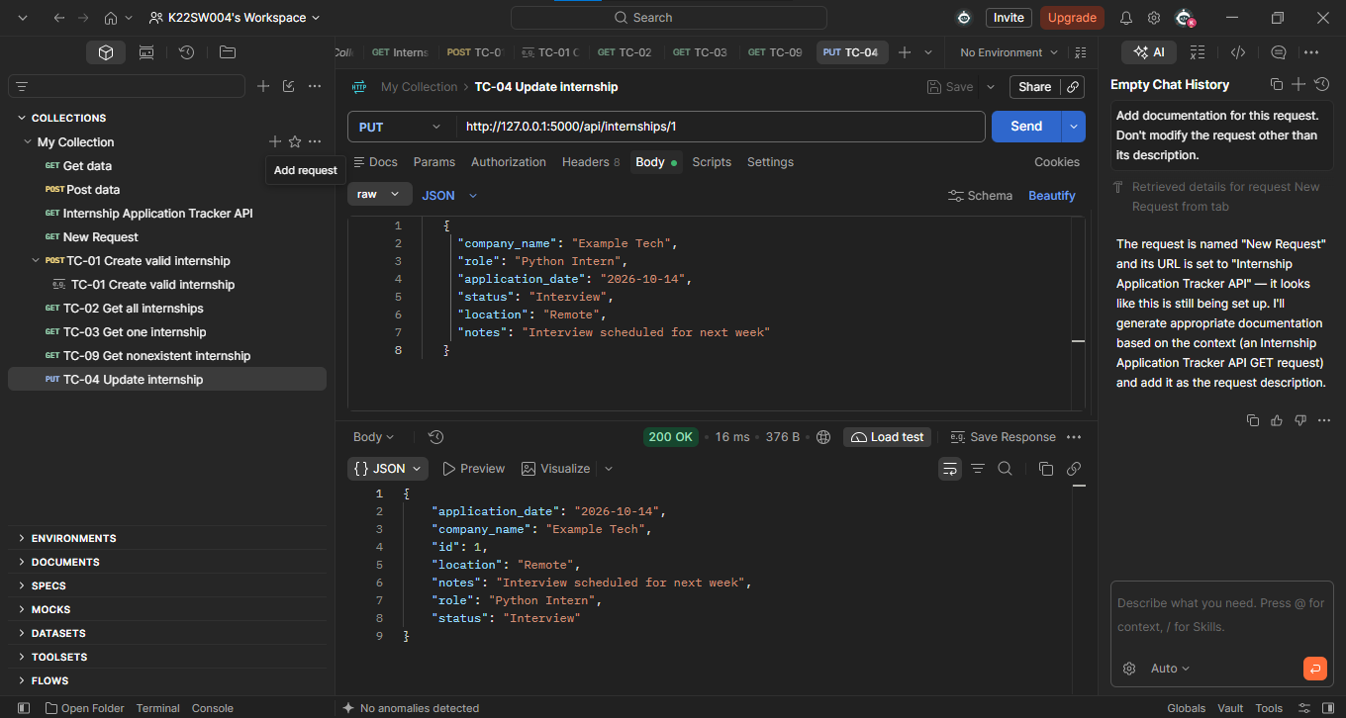
- Figure 7.5: TC-05.png (DELETE, 200 OK)
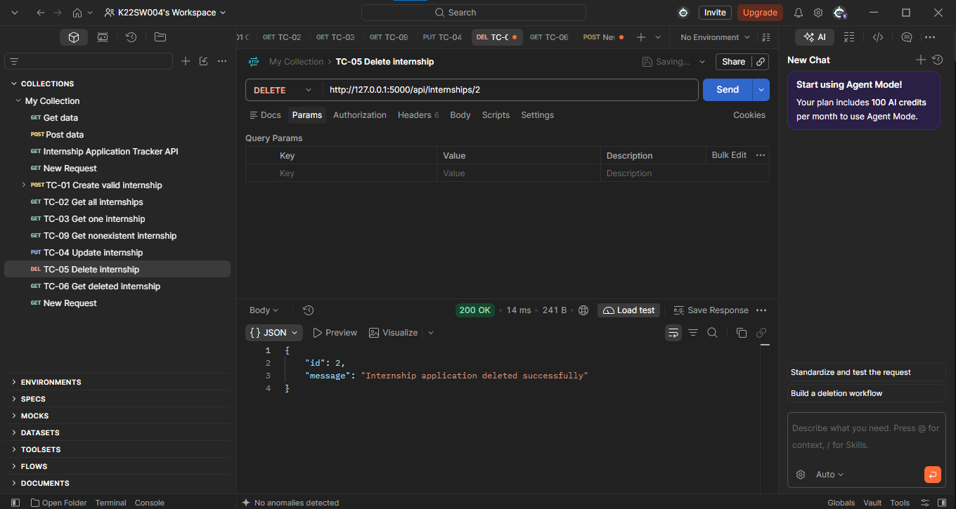
- Figure 7.6: TC-06.png (GET deleted record, 404 Not Found)
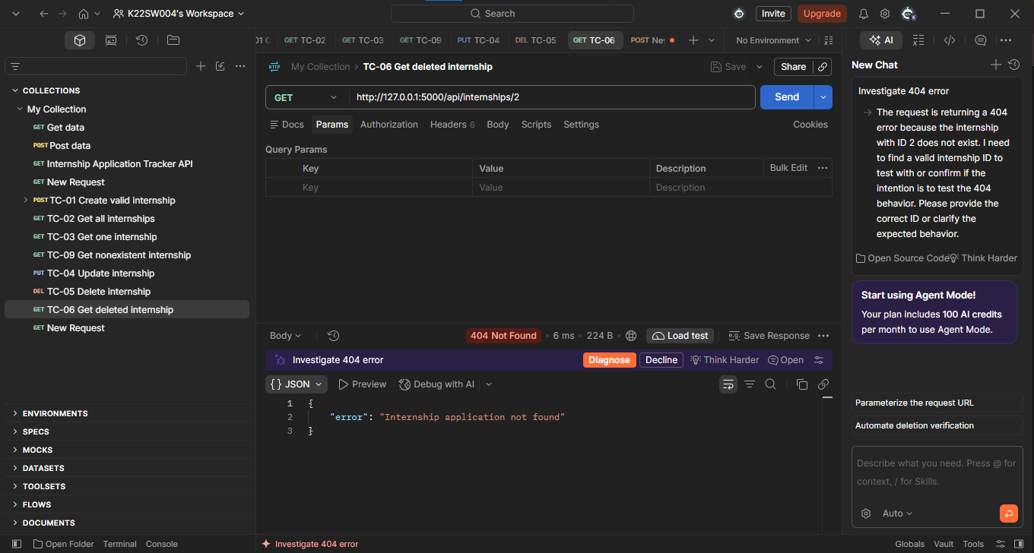

7.3 Automated run with the Collection Runner
The collection contains 28 requests: 26 test cases and 2 support requests (TC-05-prep creates the disposable record and TC-99 deletes the test record afterwards so the collection can be run again). The Postman run results screen reported: 1 iteration, 85 tests, 85 passed, 0 failed, 0 errors, total duration 3 s 250 ms and average response time 18 ms.
Figure 7.7: Collection Runner summary showing 85 tests, 85 passed, 0 failed
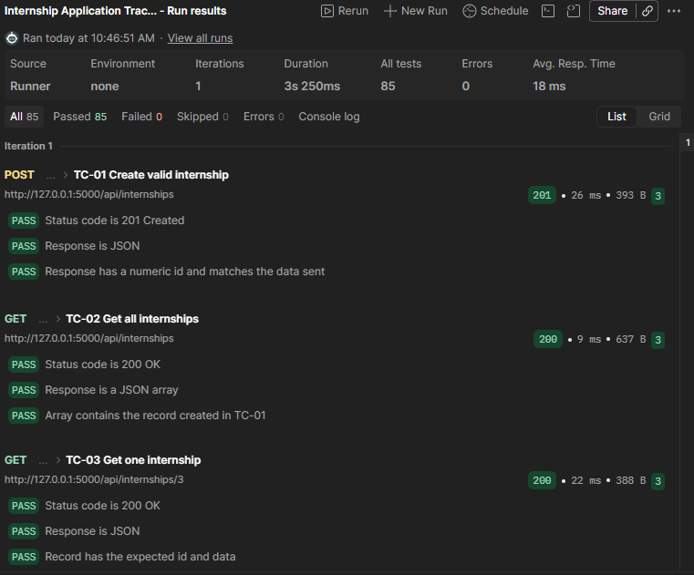
Figure 7.8 Runner results list
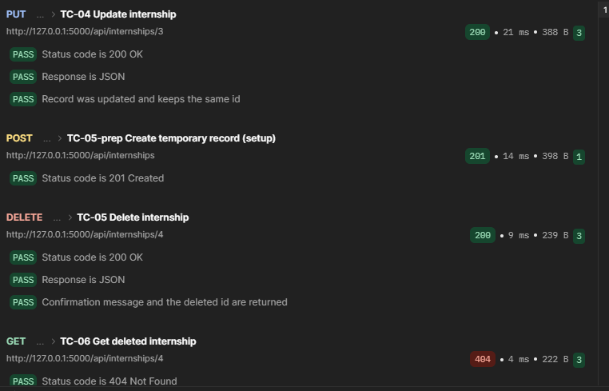
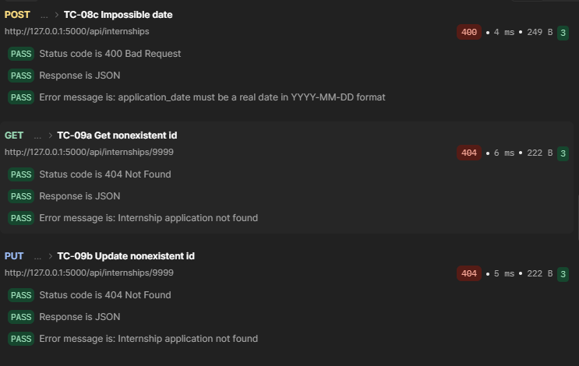
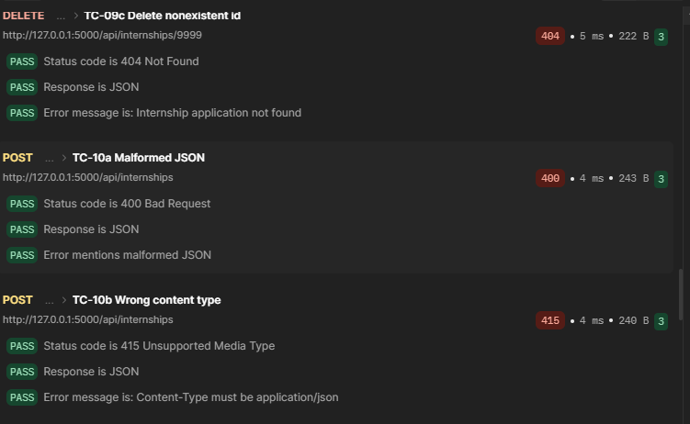
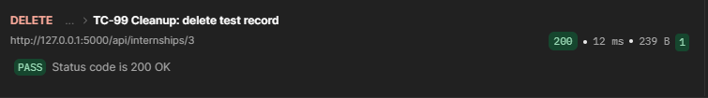

7.4 Persistence test
ID | Objective and request | Expected result | Actual result | Result
TC-17 | Create a record, stop and restart the server, then GET the same id | 200 OK with the same data after the restart | 200 OK | Pass

Figure 7.9: POST response, GET response after the restart

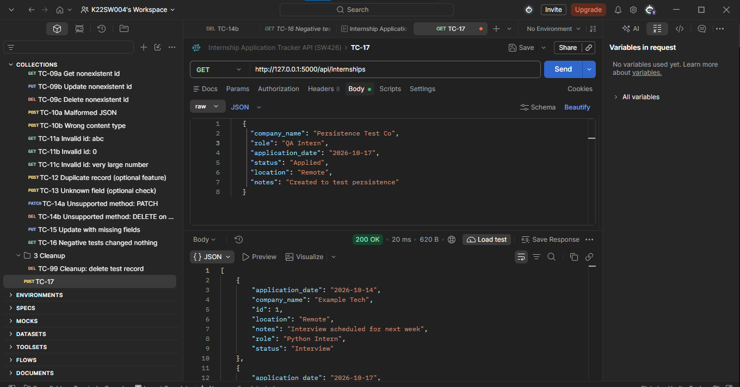

8. Error-Handling and Validation Tests
These tests send invalid data, missing fields, incorrect IDs, malformed JSON, a wrong content type and unsupported methods. Each request must be rejected with the correct status code and a clear JSON message, and the database must not change. The expected database change is none for every test in this section. TC-16 confirms this through the API, and show_db.py was run before and after the tests.
ID | Objective and request | Expected status | Expected response | Actual status | Result
TC-07a | POST without company_name | 400 | Missing required fields; the fields list contains company_name | 400 | Pass
TC-07b | POST with an empty company_name | 400 | company_name must be a non-empty string | 400 | Pass
TC-07c | POST with a role of only spaces | 400 | role must be a non-empty string | 400 | Pass
TC-08a | POST with status Maybe | 400 | status must be one of the allowed values; the allowed values are listed | 400 | Pass
TC-08b | POST with date 16/10/2026 | 400 | application_date must be a real date in YYYY-MM-DD format | 400 | Pass
TC-08c | POST with date 2026-13-45 | 400 | Same message as TC-08b | 400 | Pass
TC-09a | GET /api/internships/9999 | 404 | Internship application not found | 404 | Pass
TC-09b | PUT /api/internships/9999 with a valid body | 404 | Internship application not found | 404 | Pass
TC-09c | DELETE /api/internships/9999 | 404 | Internship application not found | 404 | Pass
TC-10a | POST with a malformed JSON body | 400 | Malformed JSON: the body is empty or not valid JSON | 404 | Pass
TC-10b | POST with valid data sent as text/plain | 415 | Content-Type must be application/json | 404 | Pass
TC-11a | GET /api/internships/abc | 400 | ID must be a positive whole number | 404 | Pass
TC-11b | GET /api/internships/0 | 400 | ID must be a positive whole number | 404 | Pass
TC-11c | GET /api/internships/99999999999999999999 | 400 | ID must be a positive whole number | 404 | Pass
TC-12 | POST with the same company, role and date as an existing record (optional feature) | 409 | An application for this company, role and date already exists | 404 | Pass
TC-13 | POST with an unknown field (salary) | 400 | Unknown field(s); the fields list contains salary | 404 | Pass
TC-14a | PATCH /api/internships/{recordId} | 405 | HTTP method not allowed for this endpoint | 404 | Pass
TC-14b | DELETE /api/internships (no id) | 405 | HTTP method not allowed for this endpoint; nothing is deleted | 404 | Pass
TC-15 | PUT /api/internships/{recordId} with only the status field | 400 | Missing required fields; lists company_name, role and application_date | 404 | Pass
TC-16 | GET all after the negative tests | 200 | Row count equals the count after TC-02, and the TC-04 record still has status Interview | 404 | Pass

9. Results and Identified Issues

9.1 Results
- Automated run: the Collection Runner executed all 28 requests. All 85 checks passed and none failed (Figure 7.7).
- Database check: after the automated run only the original record (id 1) remained in the database. The cleanup request had removed the test data (Figure 9.1).
Figure 9.1: output of python show_db.py
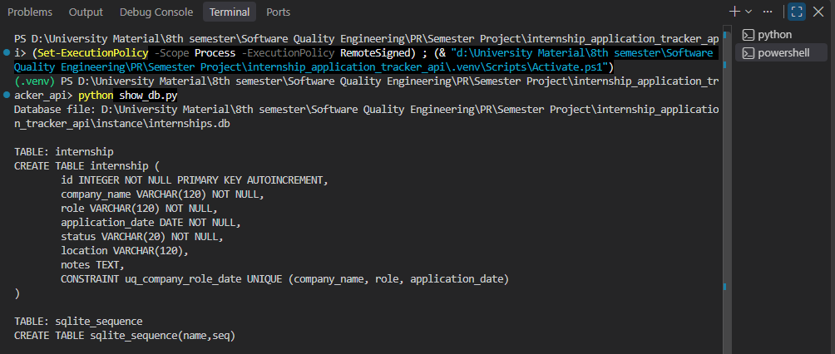

9.2 Issues identified and corrected
These issues were identified during review of the starter code and corrected in this project (see Section 4.3).
Issue | Correction | Test case
A very large ID caused an unhandled server error | IDs are validated and a JSON 400 is returned | TC-11c
Non-numeric and zero IDs gave an unhelpful message | Clear 400 message | TC-11a, TC-11b
IDs of deleted records could be reused | AUTOINCREMENT | Record IDs keep increasing
No text length limits | Length validation | Section 6.6
Date format depended on the Python version | Strict YYYY-MM-DD check | TC-08b, TC-08c
Unknown fields were handled differently in POST and PUT | One consistent rule | TC-13
Malformed JSON and a non-object body shared one message | Separate messages | TC-10a
Duplicate records could be stored | Unique rule and 409 (optional) | TC-12
PUT accepted partial updates | PUT needs the full record | TC-15
Unexpected errors returned an HTML page | JSON 500 handler | Not exercised in Postman

9.3 Limitations
- The server runs in Flask debug mode, which is suitable for local testing but not for production.
- There is no authentication, because the assignment does not require it.
- The status values and the duplicate check are case-sensitive.
- GET all returns every record, without pagination or filtering.
- The JSON 500 handler was not exercised through Postman.
- The 1000-character limit on notes is a design choice, not an assignment requirement.
- All tests ran on the local machine (127.0.0.1) and the project was not deployed.

10. Conclusion
The project delivers a working REST API for managing internship applications. It supports Create, Read, Update and Delete with persistent SQLite storage, exchanges data in JSON and returns appropriate status codes. Input validation and error handling were strengthened compared with the starter code. The API was tested in Postman with valid requests, invalid data, missing fields, incorrect and deleted IDs, malformed JSON and unsupported methods, and the database was inspected to confirm the changes. The work showed how a clear test plan with expected results, status codes and database checks can reveal weaknesses in an API before it is used.
Possible future improvements not implemented here: authentication, pagination and filtering by status, continuous integration with automated tests, and deployment.

11. GitHub Repository
[ADD the GitHub repository URL here.] The repository contains app.py, requirements.txt, show_db.py, README.md, .gitignore and the Postman collection. Before submitting, open the link in a private browser window to confirm that it is accessible.

12. Presentation Video
[ADD the video URL here.] The video demonstrates the purpose of the project and the chosen entity, the database connection and stored records, all four CRUD operations in Postman, the JSON requests and responses, the status codes with at least one error-handling scenario, and the GitHub repository with the project running. Before submitting, open the link in a private browser window to confirm that it is accessible.

THE END

